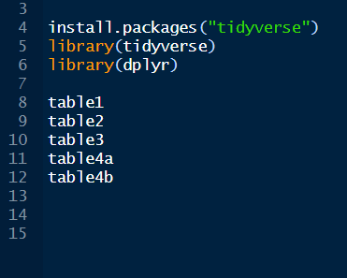

Age package install kore ai table gula import koro. Aigula built in data.

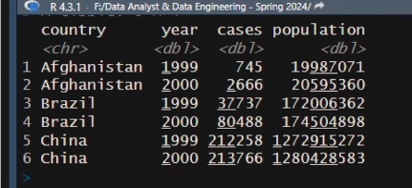

Aikhane just case and population er numeric count kora jabe. Onno konotar kora jabe na.

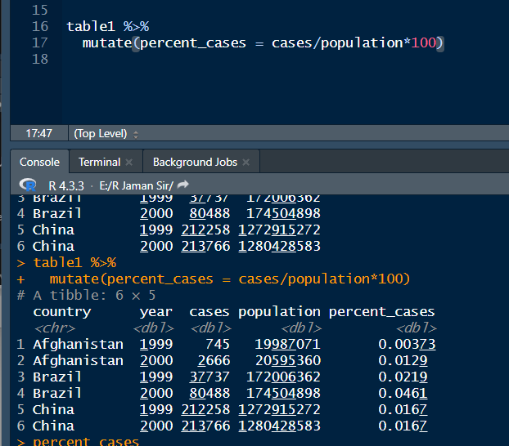

Percent banailam

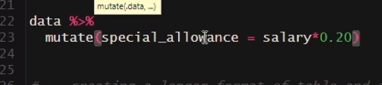

Aita salary increment

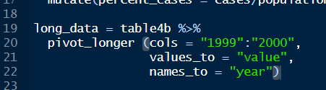

Aikhane 1999 sonkha, still string akare disi. coz table4b te aitar man level akare ache.

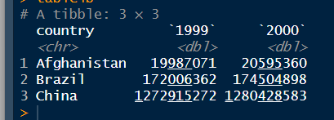

Aije dekho, level hisabe ache.

R bollo amon long data korbo column komaya jokhon row barano hoy.

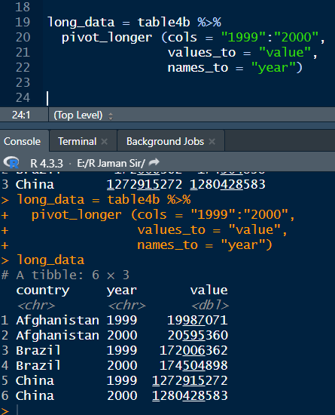

Aikhane dekho long korsi ager table ta ke.

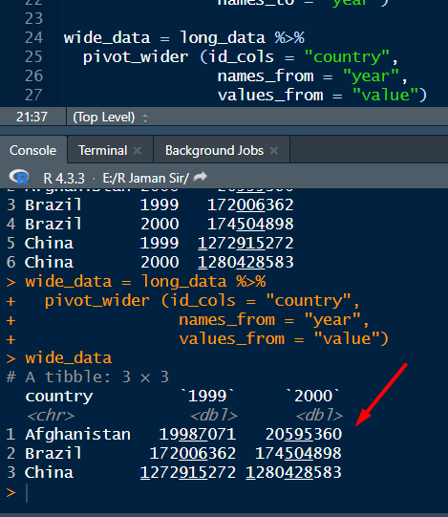

Aije wide korlam amdr just create kora long data ta ke.

Pivot long korle tokhon column select korte hoy, jegulake ami sokuchito korbo.

Pivot wide e select korbo kon column ta sthir thakbe.

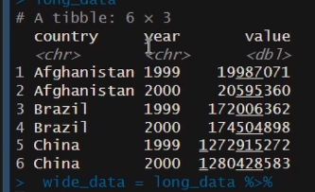

Aikhane year gula serially nai. Ami chai 1999 shob aksathe, then 2000 gula aksathe.

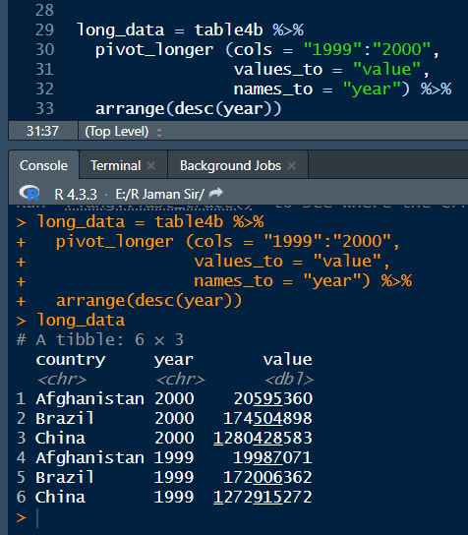

Aije year gula descend korlam. R auto aescd thake, tai oita korte parlam na.

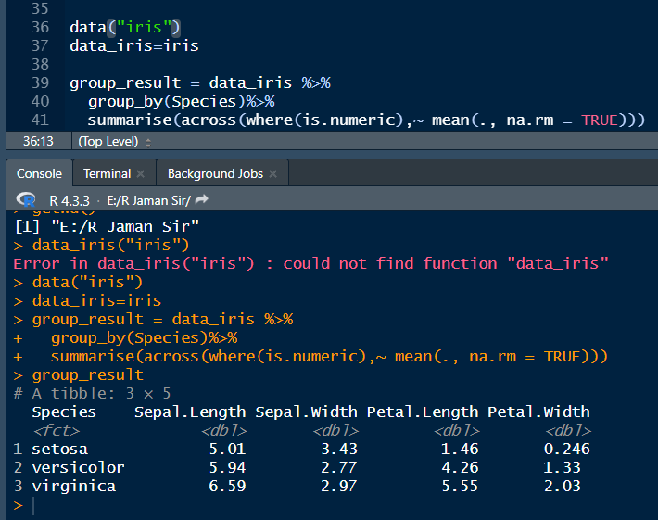

Age je group er mean korsilam, aita arekvabe korlam.

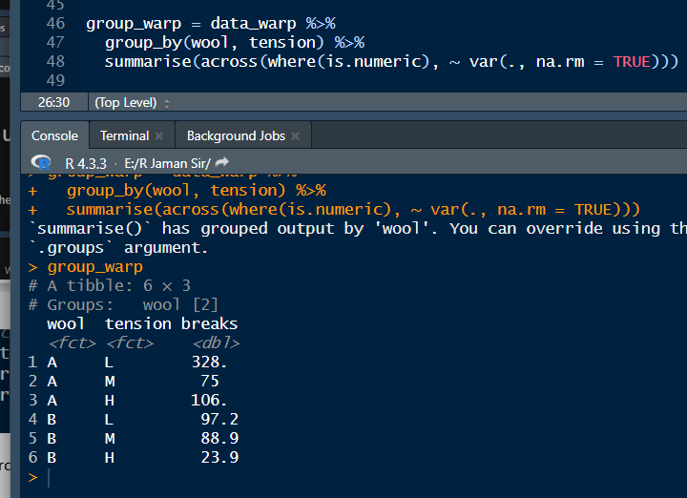

Aikhane dekho 2 ta group niye kaj korsi. Mutual arki. R ami wool and tension nisi, coz age thekei dekhsi je ai 2 ta non-numeric.

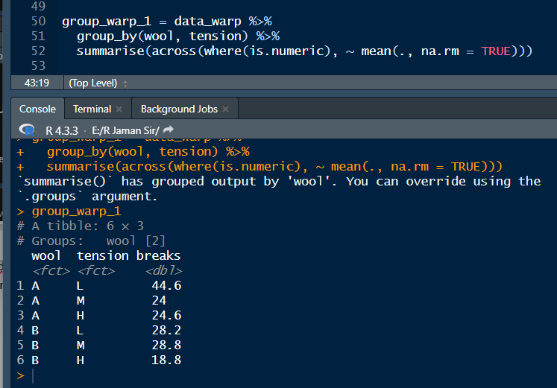

Mean o ber korlam akhon.

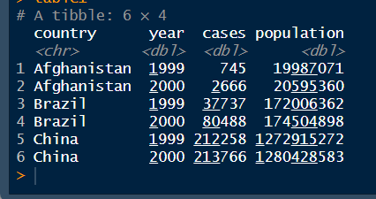

Ai file ta dekho. Aikhane ami count korbo cases on the bvasis of year.

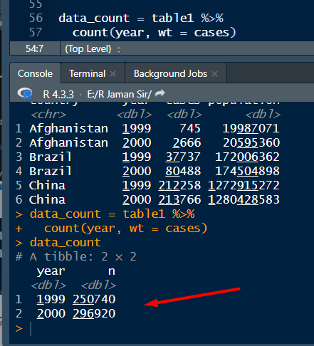

Aije dekho count korlam.

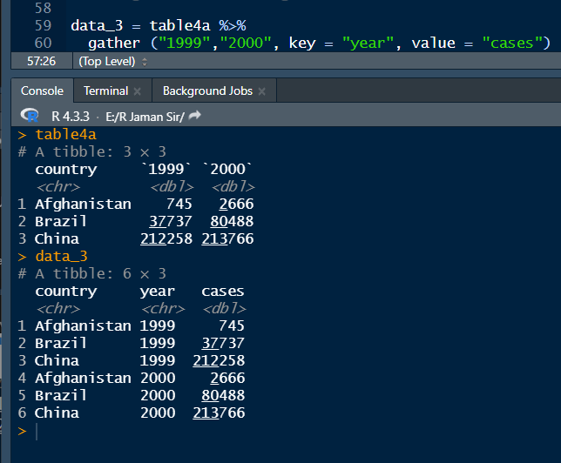

Dekho. Aikhane gather kore long kore fellam. Wide chilo as 1999 2000 pasapasi chilo.

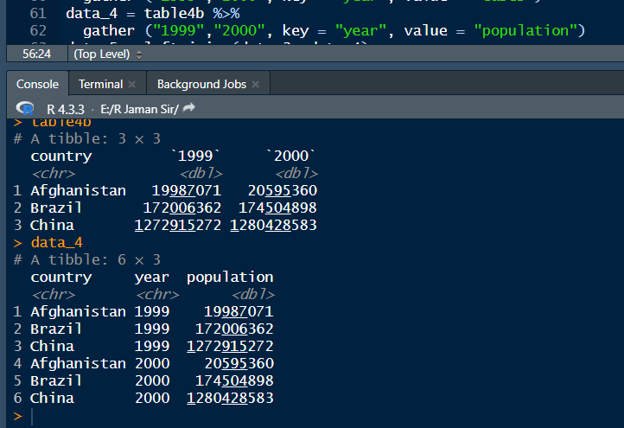

Table4b ta ke amon korlam.

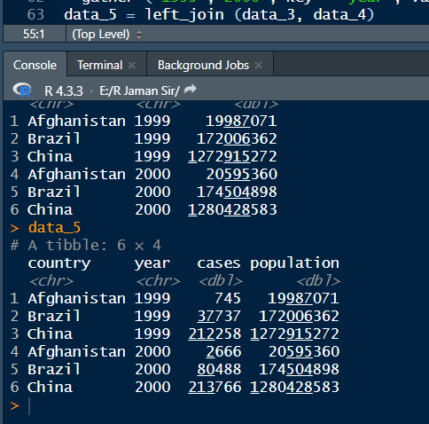

Add korlam 2 ta table. Aikhane jeita uncommon, oita add kore dibe just.

Same kaj ta cbind diyeo kora jay.

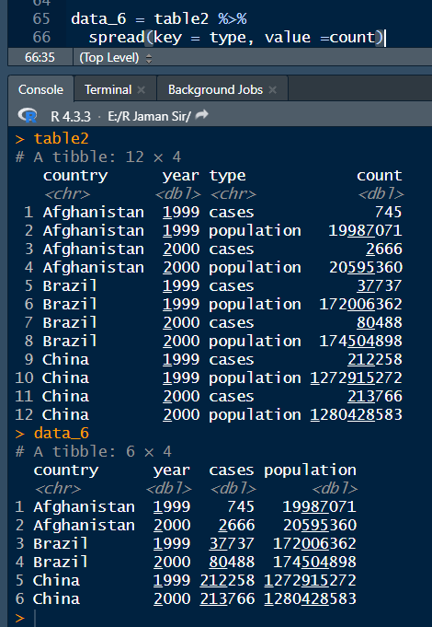

Aije aita

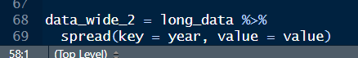

Aita arekta way wide korar.